Use-Case Realization Report (Design)
Update Question

Issue <1.0>
Revision History
Date | Issue | Description | Author
<10/Oct/09> | <1.0> | <Initial version> | <Thomas Yap>

Table of Contents
1. Brief Description 4
2. Flow of Events 4
2.1 Standard Flow 4
2.1.1 Update Question 4
3. Interaction Diagrams 5
3.1 Collaboration Diagram for Update Question 5
3.2 Sequence Diagram for Update Question 6
4. Participating Objects 6
5. Class Diagrams 7
5.1 Class Diagram for Update Question 7
6. Derived Requirements 7

Use-Case Realization Report
Update Question

Brief Description
This use case enables the controller to update new questions to Question Pool. It involves displaying the menu and form and question list to update the record.

Flow of Events
The standard flow of events for this use case and any exceptions are described in the following subsections. The events are described in terms of Actors and Analysis Objects.

Standard Flow
This use case covers the Question Maintenance - Update Question. The standard flows of these events are described below.

Update Question
The running of the application is shown in section 3.1. The flow of event is as follow:

- When the application start, the first operation to be performed is the startup operation of the main controller. This operation will create all the control objects and the entity objects necessary for operation Update Question:
  - The control object created is: MCQBL Controller
  - The entity objects create are: mcq_exam_master, mcq_section_master, mcq_question_master and mcq_question_option

- The main controller will start the main function menu:
  - To start Update Question, operation page_load() is activated by MCQBL Controller to display a Question form.
  - PopulateObjectList() will retrieve a title list of Question for Portal Admin to select to be displayed on form Question.
  - The record is displayed on form QuestionMaintenance and Portal Admin is to change any details in the form. Upon confirmation, the record will then be updated to table using operation updatequestion() to entity object mcq_question_master and mcq_question_option.
  - The adding request can be cancelled by clicking cancel button and no data will be altered.
  - A confirmation message will be displayed by form QuestionMaintenance interface.

- Step 2 will be repeated until all updates are completed. Then controller will terminate the application by issuing operation close.

Interaction Diagrams

Collaboration Diagram for Update Question
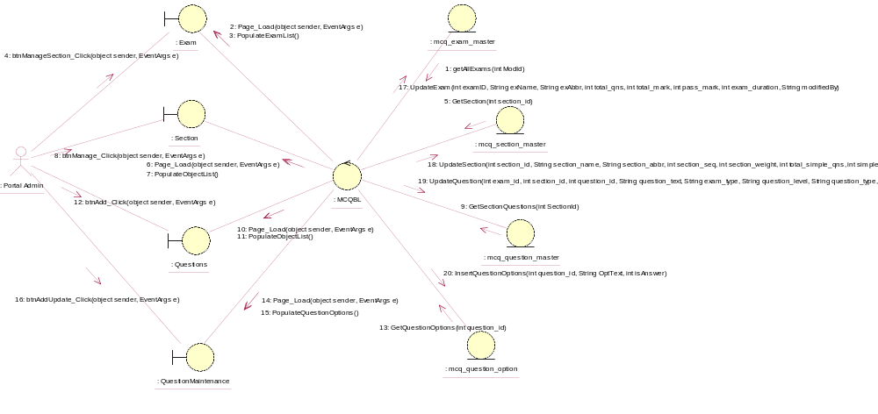

Sequence Diagram for Update Question
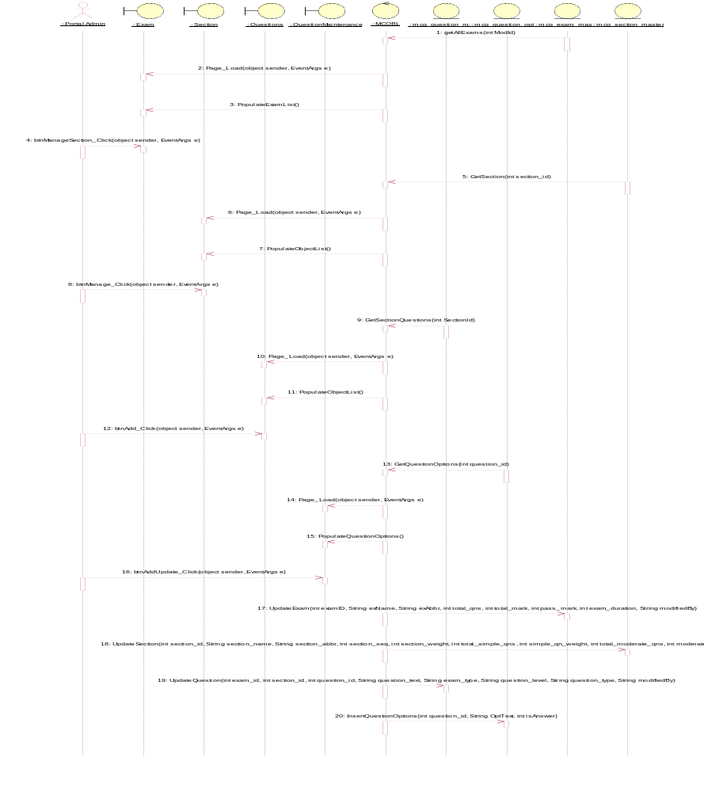

Participating Objects
: Exam

: mcq_exam_master

: mcq_question_master

: mcq_question_option

: mcq_section_master

: MCQBL

: Portal Admin

: QuestionMaintenance

: Questions

: Section

Class Diagrams

Class Diagram for Update Question
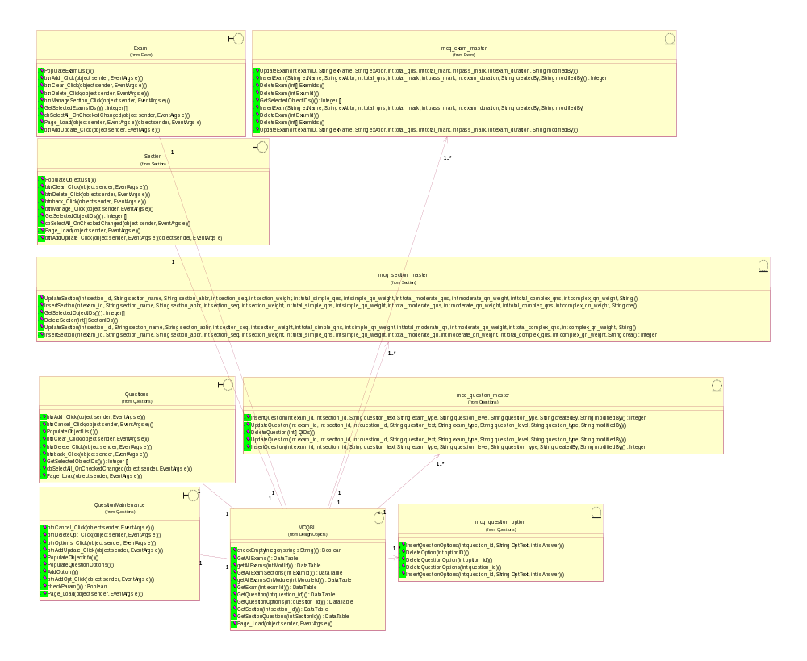

Derived Requirements
[enter the derived requirements here]

